ETX-2i-10G 19”
Final Test Instructions

Last Updated: 7.1.18

Contents
1.1. EXT CLK Test 3
1.2. SYNC-E Test 3
Appendix A. UUT Configure for EXT CLK Test 6
Appendix B. UUT & AUX Configure for SYNC-E Test 7

EXT CLK Test
1. Verify that SD led of EXT CLK port is off.
2. Configure the UUT as specified in Appendix D.
3. Type: configure system clock
domain 1
show status
4. Verify the following message:
System Clock Source : 0 State : Freerun
5. Connect a E1 source to ETX CLK connector (RJ)
6. Verify that SD led of EXT CLK port lights (green).
7. Wait few seconds and Type: show status.
8. Verify the following message:
System Clock Source : 1 State : Locked

SYNC-E Test
- Assemble the Set up the following layout :
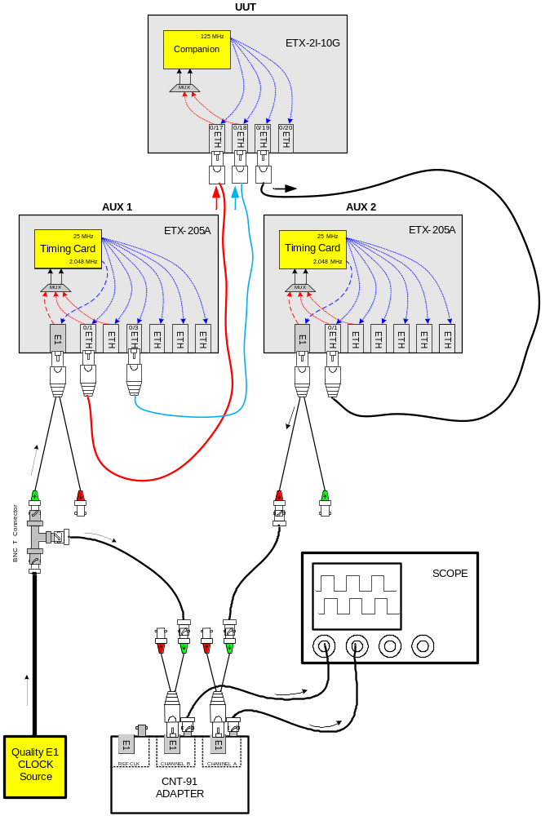
- Configure the UUT as specified in Appendix E.
- In UUT type the following commands:
configure system clock
domain 1
show status
- Wait until the following message will appear:
System Clock Source : 2 State : Locked Quality : PRC
Station Out Clock Source : 2 State : Locked
- Verify on the digital scope that the 2.048 MHz CLK appears and locked in CH1 & CH2 of the scope.
- Verify on the digital scope that the jitter of CH2 doesn’t exceeds ±30nSec in each UUT’s port test.

Note | This test is done Only in ETX-2I-10G/…./PTP.

- UUT Configure for EXT CLK Test

Type the following commands:
exit all
configure system clock station 1/1
shutdown
line-code hdb3
no shutdown
exit
domain 1
source 1 station 1/1
quality-level prc
priority 1
wait-to-restore 0
exit all
- UUT & AUX Configure for SYNC-E Test

For AUX1
Type the following commands:
exit all
config
system
clock
master 1 ptp g.8275-1
priority2 0
no shutdown
exit
domain 1
force-t4-as-t0
source 1 rx-port ethernet 6
quality-level prc
wait-to-restore 0
clear-
exit
exit
exit
exit
port
ethernet 1
tx-ssm
exit
ethernet 3
tx-ssm
exit

svi 1
no shutdown
exit
exit
flows
classifier-profile "all" match-any match all
classifier-profile "untagged" match-any match untagged

flow "eth1_svi1"
classifier "untagged"
policer profile "Policer1"
ingress-port ethernet 1
egress-port svi 1
no shutdown
exit
flow "svi1_eth1"
classifier "all"
policer profile "Policer1"
ingress-port svi 1
egress-port ethernet 1 queue 0 block 0/1
no shutdown
exit
exit

system
clock
ptp-port 1 g.8275-1
port 1
bind svi 1
state master
no shutdown
exit
exit
exit
exit

For AUX2
Type the following commands:
exit all
Config
system
clock
domain 1
force-t4-as-t0
source 1 rx-port ethernet 1
quality-level prc
wait-to-restore 0
exit
exit
exit
exit

port
l2cp-profile "ssm"
mac "01-80-c2-00-00-02" peer
exit

ethernet 1
l2cp profile "ssm"
exit
exit

For UUT
Type the following commands:
exit all
Config
system
clock
recovered 0/1 ptp g.8275-1
no shutdown
exit

domain 1
source 2 rx-port ethernet 0/18
quality-level prc
wait-to-restore 0
clear-
exit
exit
exit
exit

port
svi 1 no shutdown
l2cp-profile "ssm"
mac "01-80-c2-00-00-02" peer
exit

ethernet 0/17
l2cp profile "ssm"
exit
ethernet 0/18
l2cp profile "ssm"
exit
ethernet 0/19
tx-ssm
exit

exit

flows
classifier-profile "untagged" match-any match untagged
classifier-profile "all" match-any match all

flow "eth1_svi1"
classifier "untagged"
policer profile "Policer1"
ingress-port ethernet 0/17
egress-port svi 1 queue 1
no shutdown
exit
flow "svi1_eth1"
classifier "all"
policer profile "Policer1"
ingress-port svi 1
egress-port ethernet 0/17 queue 0 block 0/1
no shutdown
exit
exit

system
clock
ptp-port 0/1 g.8275-1
port 17
bind svi 1
no shutdown
exit
exit
exit
exit

